AMLTA - LITERATURE SURVEY
AI-Based Early Detection of Alzheimer's Disease Using Speech and Machine Learning
Section: 1
Team : 3
Bhanu Prakash - 2420030209
Krishitha Myneni - 2420030443
Laasya Priya - 2420030002
S.No | Paper Title | Paper Link | Year & Author(s) | Limitations | How We Solved It
1 | Linguistic Features Identify Alzheimer's Disease in Narrative Speech | https://doi.org/10.3233/JAD-150520 | 2015 – K. C. Fraser, J. A. Meltzer, F. Rudzicz | Relies on hand-crafted features (POS ratios, type–token ratio, information units) that need manual design and domain expertise. Cannot learn contextual or long-range patterns in discourse. | Replaced manual feature engineering with end-to-end representation learning using DeBERTa-v3-base. The encoder learns contextual features directly from raw transcripts.
2 | Alzheimer's Dementia Recognition through Spontaneous Speech: The ADReSS Challenge | https://doi.org/10.21437/Interspeech.2020-2571 | 2020 – S. Luz, F. Haider, S. de la Fuente, D. Fromm, B. MacWhinney | Baseline acoustic and linguistic models reached only about 75% accuracy. Results were reported as point estimates with no component-level analysis. | Used a pre-trained transformer encoder that outperformed the challenge-baseline level. A controlled four-configuration ablation isolates the contribution of each pipeline component.
3 | To BERT or Not to BERT: Comparing Speech and Language-Based Approaches for Alzheimer's Disease Detection | https://doi.org/10.21437/Interspeech.2020-2557 | 2020 – A. Balagopalan, B. Eyre, F. Rudzicz, J. Novikova | Uses default [CLS]-token pooling, so scattered linguistic evidence must pass through one fixed position. Reports single runs without confidence intervals. | Added a learned additive attention-pooling head that weights every non-padding token. This raised test accuracy from 74.67% to 78.67% and MCC from 0.510 to 0.588. Every result carries a 95% Wilson interval.
4 | Disfluencies and Fine-Tuning Pre-Trained Language Models for Detection of Alzheimer's Disease | https://doi.org/10.21437/Interspeech.2020-2516 | 2020 – J. Yuan, Y. Bian, X. Cai, J. Huang, Z. Ye, K. Church | High variance across fine-tuning runs required ensembling. Uses older BERT/ERNIE encoders that are less sample-efficient on small data. | Adopted DeBERTa-v3, whose disentangled attention and ELECTRA-style pre-training improve sample efficiency on a 347-document training set. Disfluencies are preserved verbatim as diagnostic signal.
5 | Pauses for Detection of Alzheimer's Disease | https://doi.org/10.3389/fcomp.2020.624488 | 2021 – J. Yuan, X. Cai, Y. Bian, Z. Ye, K. Church | Depends on pause timing from audio alignment, so it is not a pure text-only pipeline. Instability across runs is not statistically quantified. | Built a strictly transcript-only pipeline with minimal cleaning that retains repetitions, false starts and filled pauses. Uncertainty is quantified with Wilson CIs and a bounded McNemar analysis. Explicit pause tokens are identified as future work.
6 | Comparing Natural Language Processing Techniques for Alzheimer's Dementia Prediction in Spontaneous Speech | https://doi.org/10.21437/Interspeech.2020-2729 | 2020 – T. Searle, Z. Ibrahim, R. Dobson | Compares whole model families rather than individual pipeline components. Reports no paired significance tests. | Held the dataset, split, seed, tokenizer and sequence length constant while varying one component at a time (pooling, loss, optimisation regime). Paired comparisons use a bounded McNemar test.
7 | Recognition of Alzheimer's Dementia from the Transcriptions of Spontaneous Speech Using fastText and CNN Models | https://doi.org/10.3389/fcomp.2021.624558 | 2021 – A. Meghanani, C. S. Anoop, A. G. Ramakrishnan | Static word embeddings (fastText) cannot capture context-dependent meaning. CNNs capture only local n-gram patterns. | Used contextual subword embeddings from a 184M-parameter DeBERTa-v3 encoder. Subword tokenization keeps malformed or partial words as recognisable token sequences.
8 | Automated Screening for Alzheimer's Dementia through Spontaneous Speech | https://doi.org/10.21437/Interspeech.2020-3158 | 2020 – M. S. S. Syed, Z. S. Syed, M. Lech, E. Pirogova | Pooling is applied over frozen transformer embeddings, so the encoder is not adapted to the task. | Fine-tuned all encoder parameters end-to-end jointly with a learnable attention-pooling head (about 98k parameters, 0.05% of the encoder).
9 | An Assessment of Paralinguistic Acoustic Features for Detection of Alzheimer's Dementia in Spontaneous Speech | https://doi.org/10.1109/JSTSP.2019.2955022 | 2020 – F. Haider, S. de la Fuente, S. Luz | Acoustic-only features miss much of the lexical and semantic signal that carries most of the discriminative information. | Focused on the linguistic channel through transformer-based transcript modelling. Multimodal fusion with acoustic features is proposed as an extension.
10 | Detecting Signs of Dementia Using Word Vector Representations | https://doi.org/10.21437/Interspeech.2018-1753 | 2018 – B. Mirheidari, D. Blackburn, T. Walker, A. Venneri, M. Reuber, H. Christensen | Word-vector representations lack deep contextual modelling and document-level aggregation. | Used deep contextual token states H ∈ ℝ^(256×768) aggregated by masked-softmax attention into a document vector.
11 | Detecting Cognitive Decline Using Speech Only: The ADReSSo Challenge | https://doi.org/10.21437/Interspeech.2021-1220 | 2021 – S. Luz, F. Haider, S. de la Fuente, D. Fromm, B. MacWhinney | Performance drops on ASR transcripts. Challenge results rarely report uncertainty or negative findings. | Reported negative results as primary findings. Class weighting gave 92% validation but only 76% test accuracy, and this is reported openly with full uncertainty analysis.
12 | Artificial Intelligence, Speech and Language Processing Approaches to Monitoring Alzheimer's Disease: A Systematic Review | https://doi.org/10.3233/JAD-200888 | 2020 – S. de la Fuente Garcia, C. W. Ritchie, S. Luz | Finds that most studies use small datasets, lack reproducibility and report weak statistical validation. | Conducted a reproducibility audit that documents a label-count discrepancy with an exhaustive sensitivity analysis (E5 range 81.33–84.00%). A speaker-disjoint, multi-seed confirmation protocol is specified.
13 | On the Stability of Fine-Tuning BERT: Misconceptions, Explanations, and Strong Baselines | https://arxiv.org/abs/2006.04884 | 2021 – M. Mosbach, M. Andriushchenko, D. Klakow | Shows that small-dataset fine-tuning is unstable, but does not address clinical speech data specifically. | Applied a conservative bundled regime for small data (learning rate 1×10⁻⁵, weight decay 0.05, 6 epochs, 26 warmup steps). It was associated with the highest held-out accuracy (82.67%, provisional).
14 | Fine-Tuning Pretrained Language Models: Weight Initializations, Data Orders, and Early Stopping | https://arxiv.org/abs/2002.06305 | 2020 – J. Dodge, G. Ilharco, R. Schwartz, A. Farhadi, H. Hajishirzi, N. Smith | Seed and data-order variance can shift accuracy by several points, and most applied studies ignore this. | Fixed the seed (42), split, and FP32 precision across all configurations so that differences come from the method, not the setup. Multi-seed grouped 10-fold cross-validation is prescribed for confirmation.
15 | DeBERTaV3: Improving DeBERTa Using ELECTRA-Style Pre-Training with Gradient-Disentangled Embedding Sharing | https://arxiv.org/abs/2111.09543 | 2023 – P. He, J. Gao, W. Chen | A general-purpose encoder that has not been evaluated for dementia detection on Pitt Cookie Theft transcripts. | Applied and ablated DeBERTa-v3-base on 497 Pitt DementiaBank Cookie Theft transcripts. To the authors' knowledge, this is the first attention-pooling and regularization ablation of it for this task.
16 | Connected Speech and Language in Mild Cognitive Impairment and Alzheimer's Disease: A Review of Picture Description Tasks | https://doi.org/10.1080/13803395.2018.1446513 | 2018 – K. D. Mueller, B. Hermann, J. Mecollari, L. S. Turkstra | A clinical review that documents group-level language differences but offers no automated system that can classify individual speakers. | Converted these clinical observations into an automated transcript-level classifier on the Cookie Theft picture-description task, keeping disfluencies and repetitions as model input.
17 | A Comparative Study of Acoustic and Linguistic Features Classification for Alzheimer's Disease Detection | https://www1.se.cuhk.edu.hk/~hccl/publications/pub/ICASSP_jcli.pdf | 2021 – J. Li, J. Yu, Z. Ye, S. Wong, M. Mak, B. Mak, X. Liu, H. Meng | Compares many feature sets and classifiers side by side, but does not isolate individual design choices inside the neural fine-tuning pipeline. No confidence intervals are reported. | Held every factor constant except the component under study. Each configuration is reported with 95% Wilson intervals, MCC and Cohen's κ.
18 | Development of the CUHK Elderly Speech Recognition System for Neurocognitive Disorder Detection Using the DementiaBank Corpus | https://www1.se.cuhk.edu.hk/~hccl/publications/pub/zye_revised_v4.pdf | 2021 – Z. Ye, S. Hu, J. Li, X. Xie, M. Geng, J. Yu, et al., X. Liu, H. Meng | Focuses on building a heavy ASR system for elderly speech. Downstream detection depends on recognition quality and large-scale acoustic training. | Uses a lightweight text-only pipeline on manual CHAT transcripts that trains in minutes on a single 8 GB laptop GPU. Evaluation on ASR transcripts is listed as a limitation and future step.
19 | Conformer Based Elderly Speech Recognition System for Alzheimer's Disease Detection | https://arxiv.org/abs/2206.13232 | 2022 – T. Wang, J. Deng, M. Geng, Z. Ye, S. Hu, Y. Wang, M. Cui, Z. Jin, X. Liu, H. Meng | Achieves high accuracy but requires a complex ASR stack (neural architecture search, speaker adaptation, system rescoring) that is costly to reproduce. | Kept the architecture simple and reproducible: one pre-trained encoder plus a ~98k-parameter attention head, with the full configuration table and a fixed seed published.
20 | BERT: Pre-Training of Deep Bidirectional Transformers for Language Understanding | https://aclanthology.org/N19-1423/ | 2019 – J. Devlin, M.-W. Chang, K. Lee, K. Toutanova | Masked-language-model pre-training is less sample-efficient, and its default [CLS] pooling compresses the whole sequence into one token. | Replaced BERT with DeBERTa-v3 (replaced-token-detection pre-training) and replaced [CLS] pooling with learned attention pooling over all tokens.
21 | DeBERTa: Decoding-Enhanced BERT with Disentangled Attention | https://arxiv.org/abs/2006.03654 | 2021 – P. He, X. Liu, J. Gao, W. Chen | Introduces disentangled attention but still relies on masked-language-model pre-training. Not evaluated on clinical speech transcripts. | Used the v3 successor, which adds ELECTRA-style pre-training and gradient-disentangled embedding sharing, and applied it to Alzheimer's transcripts.
22 | A Structured Self-Attentive Sentence Embedding | https://arxiv.org/abs/1703.03130 | 2017 – Z. Lin, M. Feng, C. N. dos Santos, M. Yu, B. Xiang, B. Zhou, Y. Bengio | Attention pooling is built on BiLSTM encoders and tested on general NLP tasks, not on low-resource clinical data. | Adapted additive attention pooling to a pre-trained DeBERTa-v3 encoder with a masked softmax so padding receives zero weight, and tested it on 497 clinical transcripts.
23 | Hierarchical Attention Networks for Document Classification | https://aclanthology.org/N16-1174/ | 2016 – Z. Yang, D. Yang, C. Dyer, X. He, A. Smola, E. Hovy | GRU-based hierarchical model trained from scratch, which needs large labelled corpora to work well. | Combined the attention-aggregation idea with transfer learning from a pre-trained transformer, making it practical for a 347-document training set.
24 | How to Fine-Tune BERT for Text Classification? | https://arxiv.org/abs/1905.05583 | 2019 – C. Sun, X. Qiu, Y. Xu, X. Huang | Fine-tuning recipes were derived on large benchmark datasets and may overfit on a few hundred documents. | Used the standard recipe as baseline E1, then observed overfitting (training loss 5.44×10⁻⁴ vs validation loss 1.07) and tested a more conservative bundled regime in E5.
25 | Attention Is Not Explanation | https://aclanthology.org/N19-1357/ | 2019 – S. Jain, B. C. Wallace | Shows attention weights can often be permuted without changing predictions, so attention alone is not a faithful explanation. | Treated attention weights only as a diagnostic signal, not as proof. An explainability protocol validating attention against LIME/SHAP is specified (not yet executed).
26 | Attention Is Not Not Explanation | https://aclanthology.org/D19-1002/ | 2019 – S. Wiegreffe, Y. Pinter | Argues attention can be meaningful, but whether it is depends on the task and model, and must be tested case by case. | Adopted the balanced position: attention weights from the pooling layer are extractable per document, but must be cross-checked with an independent attribution method before being reported as explanations.
27 | Cross-Validation Failure: Small Sample Sizes Lead to Large Error Bars | https://doi.org/10.1016/j.neuroimage.2017.06.061 | 2018 – G. Varoquaux | Shows small-sample evaluation gives wide error bars, but many clinical NLP studies still report bare point estimates. | Reported 95% Wilson intervals for every accuracy figure and openly stated that no difference is significant at n = 75. Repeated grouped 10-fold cross-validation across five seeds is specified.
28 | The Advantages of the Matthews Correlation Coefficient (MCC) over F1 Score and Accuracy in Binary Classification Evaluation | https://doi.org/10.1186/s12864-019-6413-7 | 2020 – D. Chicco, G. Jurman | Accuracy and F1 can be misleading when errors are unevenly distributed, yet many Alzheimer's detection papers report accuracy alone. | Reported MCC, Cohen's κ, balanced accuracy, specificity and recall alongside accuracy for every configuration.

Comparative Analysis
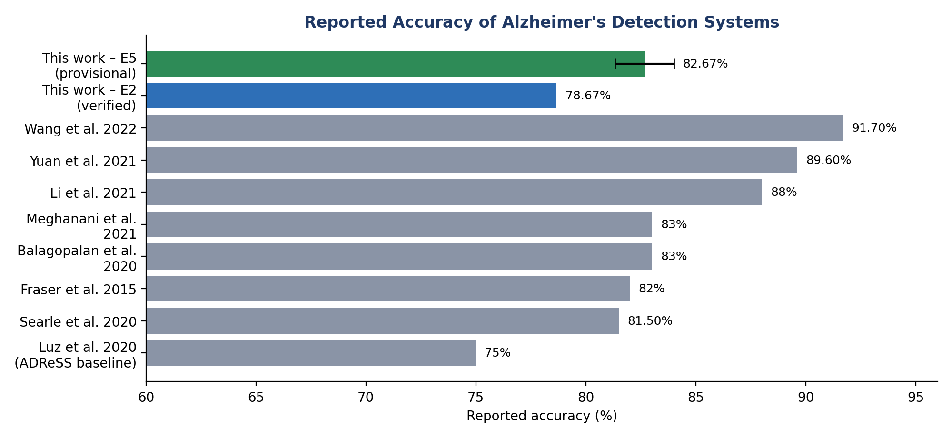
Figure 1. Reported accuracy of published Alzheimer's detection systems versus the proposed work
Datasets and evaluation protocols differ (ADReSS, Pitt-derived, manual vs ASR transcripts), so this is an orientation chart, not a leaderboard. The E5 error bar shows the 81.33–84.00% sensitivity range.
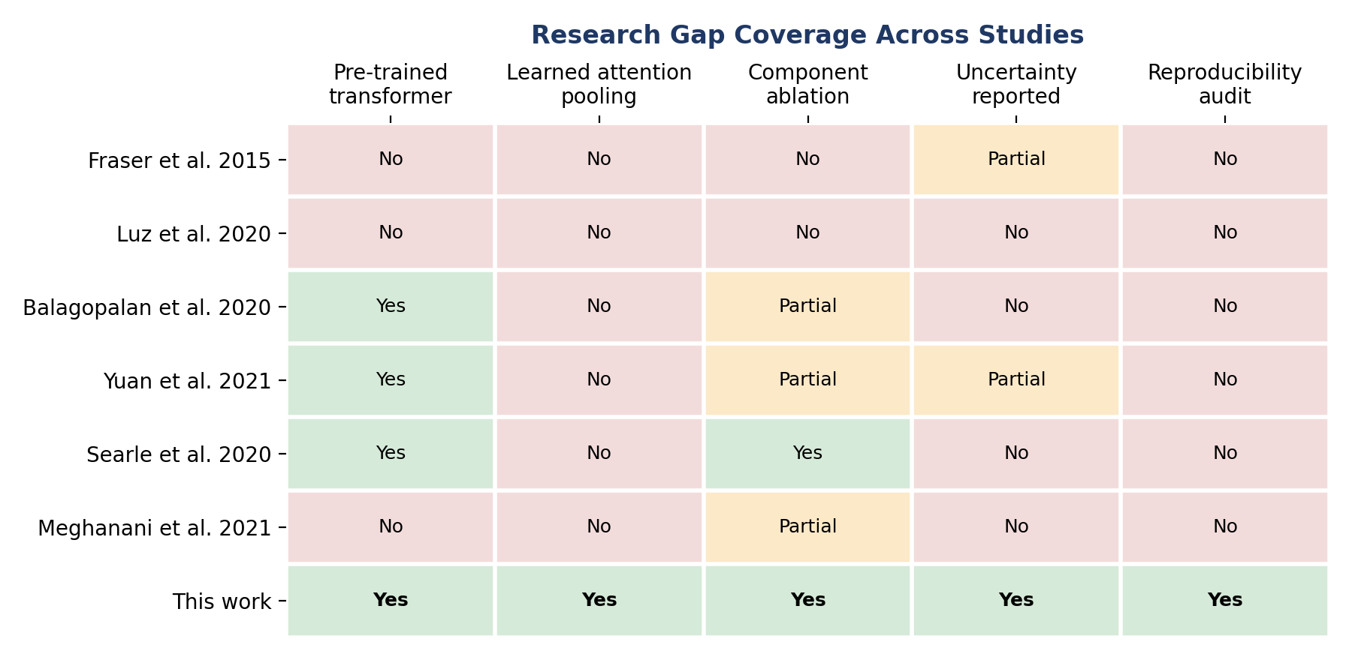
Figure 2. Research gap coverage across representative studies
Ratings for prior studies follow the critical comparison in Table 1 of the reference paper.
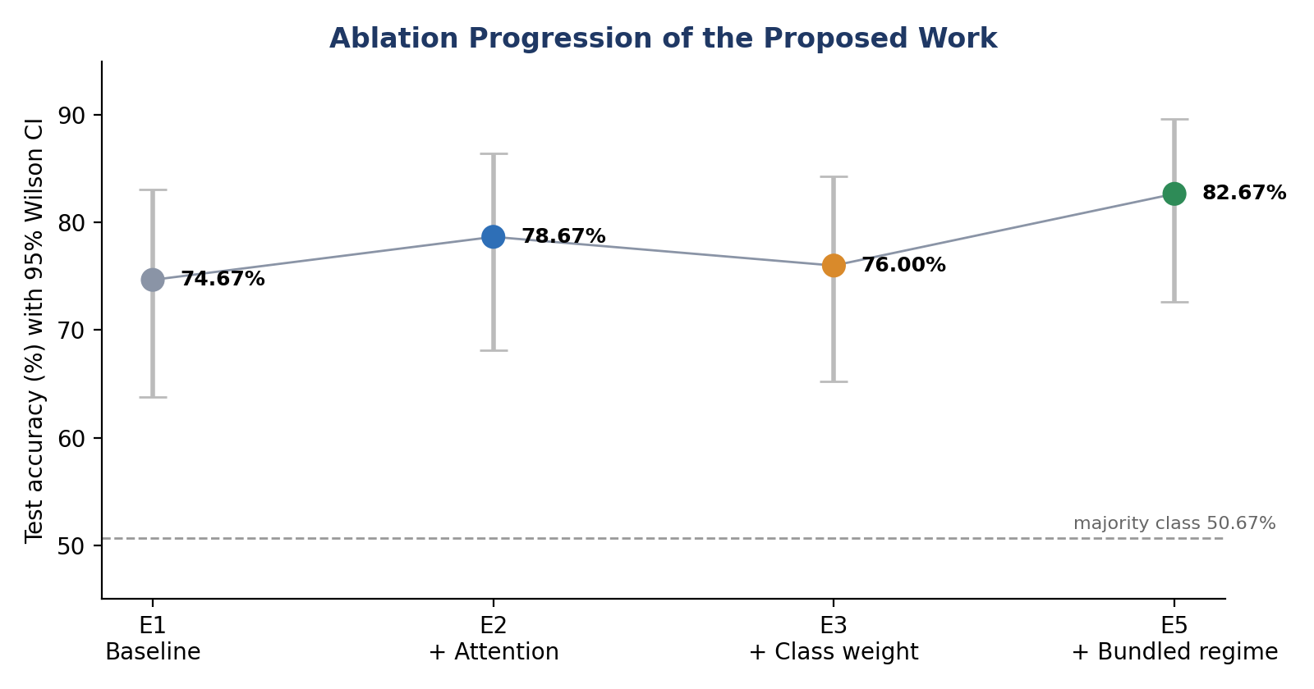
Figure 3. Ablation progression of the proposed work (test accuracy with 95% Wilson confidence intervals)
All intervals overlap; at n = 75 none of the differences is statistically significant.
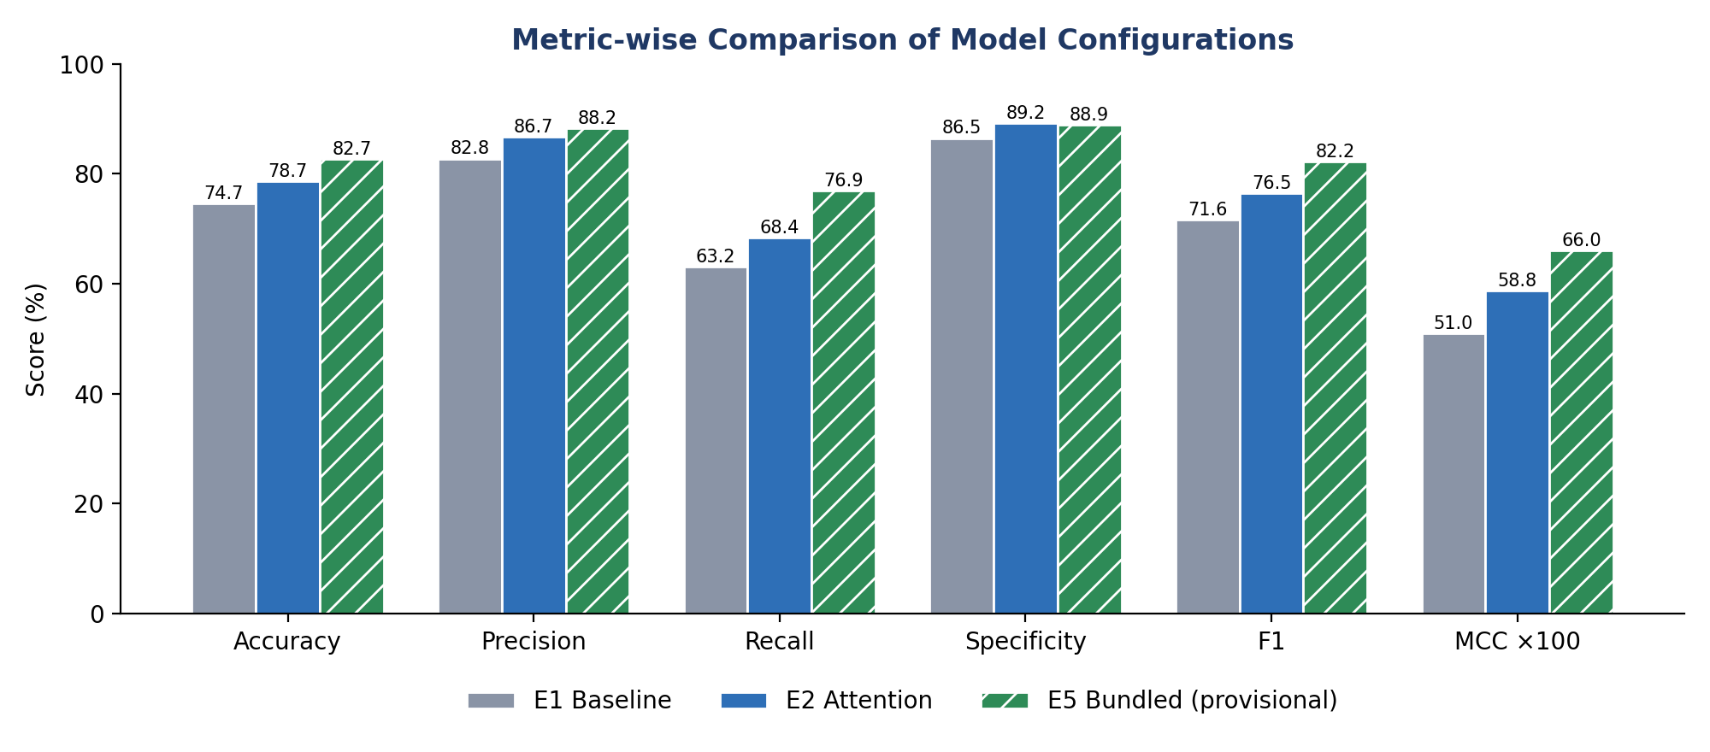
Figure 4. Metric-wise comparison of configurations E1, E2 and E5
E1 and E2 are verified against the sealed test partition; E5 values are provisional (as recorded).

Summary of the Research Gap
Earlier studies established that fine-tuned transformers can detect Alzheimer's disease from transcripts. However, they rarely isolate which pipeline component produces the gain, seldom report negative results, and usually give bare point estimates on small test sets. The present work addresses these gaps through a controlled ablation, transparent reporting of negative results, and uncertainty quantification suited to the sample size (Wilson confidence intervals, MCC, Cohen's κ and a bounded McNemar analysis).

